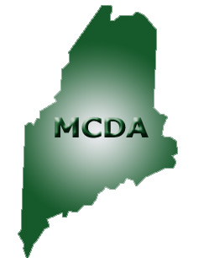
Maine Community Development Association

* 2007 CDBG Proposed Program 1

* COSCDA Annual Convention 2

* MMA Convention 2

* Town of Madawaska 3

* CEI – New Markets Tax Credit 4

* NMDC/USDA-RD
Housing Preservation Grant Program 4

* Upcoming Events 5

Executive Committee Members:

Isaac Wagner, President
Christopher Spruce, Vice President
Ron Harriman, Treasurer
Joella R. McBreairty, Secretary
Mathew Eddy, Past President

Board Members:
Mary Walton, City of Caribou
Rodney Lynch, City of Rockland
James Gulnac, Town of Sanford
Michele Gagnon, City of Ellsworth

April-June, 2006 Volume 3, Issue 2

2007 CDBG Proposed Program

The Department of Economic and Community Development, Office of Community Development posted the 2007 Community Development Block Grant Proposed Statement on their website on July 18th. The proposed CDBG appropriation for the State of Maine is $10,475,706, down by approximately 28% over the 2006 CDBG budget. The budget in 2003 was $16,968,000 and has since decreased each year to its current budget amount.

On April 27 and 28, the Office of Community Development (OCD) and the Maine Community Development Association (MCDA) held a program development and training conference to discuss proposed changes to the 2007 CDBG program. Allocating budget amounts for any of the community development, economic development, planning, and special projects programs is a necessary process that must be undertaken each year. The FY 2007 CDBG Budget Allocation is proposed as follows:

Program | Budget | Application Deadline
Housing Assistance | $1,000,000 | Letter on Intent: January 12, 2007  Application: March 2, 2007
Home Repair Network Program | $1,050,000
Public Infrastructure Grant | $2,500,000 | Letter of Intent: December 1, 2006  Application: January 12, 2007
Public Facilities Grant | $1,200,000 | Letter of Intent: December 1, 2006  Application: January 12, 2007
Public Service Grant | $200,000 | Letter of Intent: January 26, 2007  Application: March 9, 2007
Downtown Revitalization Grant | $500,000 | Application: February 9, 2007
Community Enterprise Grant | $750,000 | Application: February 9, 2007
Urgent Need Grant | $80,000 | 1st come basis beginning March 2, 2007
Economic Development Program  - Business Assistance  - Non-Profit Development  - Development Fund Loan  - Interim Financing Program  - Section 108 Loan Program | $2,500,000 | Pre-Application: February 2, 2007 and  May 4, 2007  Application: April 6, 2007 and  July 6, 2007
Community Planning | $50,000  $50,000 | Round 1: April 6, 2007  Round 2: August 3, 2007
NOTE: All applications must be received at the physical location of the Office of Community Development by 4:00 p.m. EST on the dates listed above.

2006
COSCDA
Annual
Conference

September 17 – 20, 2006
San Antonio, TX
A representative of MCDA attends the Annual Training Conference each year. The training conference offers learning opportunities for agency directors and professional community development staff who administer CDBG, HOME, and homeless programs. This year’s theme is “Community Development Delivers!” The Policy Symposium held on Sunday, September 17 is designed to provide attendees with tools to help leverage partnerships with other entities, enabling them to make a bigger difference in their communities and to help foster a stronger national community development policy. The Symposium addresses the challenges of community development in a rural setting. The conference also provides valuable information on legislative, regulatory and policy issues affecting HUD’s programs and operations.

Anyone wishing to attend this conference should make their reservation by August 16th. For more information, visit the COSCDA website at www.COSCDA.org.

MMA CONVENTION

Maine Municipal Association will be holding its 70th Annual Convention and Exposition October 4-6 at the Augusta Civic Center.
The auditorium of the Augusta Civic Center is the exhibit hall where businesses/agencies can display products, services, equipment, and informational materials to the convention delegates. The exhibit hall will open at 8:00 a.m. on Wednesday, October 4th. Exhibitors can set up either Tuesday afternoon, from 2:00 p.m. til 6:00 p.m., or Wednesday morning, starting at 7:00 a.m. The exhibit hall will be open from 8:00 a.m. til 6:00 p.m. on Wednesday, and from 8:00 a.m. til 2:00 p.m on Thursday. There will be no exhibiting on Friday, October 6th.
Proposed sessions at this year’s conference includes;
- Local Governments Need PR Too
- Understanding TABOR
- Brookings Report: What It Means to Municipal Government
- Projecting Professionalism
- TECH Town
- Finance
- Public Safety
- Land Use/Planning

As an affiliate group, MCDA maintains an effective relationship with MMA. MCDA’s goal is to provide forums to increase awareness and foster communication relating to community development issues and concerns, and to provide education and training through workshops. This goal is closely connected to MMA’s overall mission, which is to strengthen the professionalism and expertise of individuals serving municipal government.

The preliminary planning for the upcoming MMA Convention focuses on organizing programs in a more unified way in an attempt to draw more selectmen/councilors to the convention.

On July 27, at 11:00 a.m., MCDA representatives will meet with the MMA Executive Committee to discuss the results of a recent affiliate group survey. The survey was distributed to the presidents and two board members of each MMA affiliate group. The purpose of the survey is to gain a clearer understanding of the needs and concerns of MMA’s various affiliate groups. MCDA members will be updated on the results of this meeting in the next issue of the newsletter.

A Legislative Issues Meeting will also occur on Friday, October 6 at 9:00 a.m. to 11:30 a.m. at the Augusta Civic Center. MCDA representatives are invited to participate in this legislative issues meeting. The meeting will provide an opportunity for an exchange of information on draft legislative platforms and related legislative issues between MMA and affiliate groups.

Festivals and Events held in Madawaska during the past few months, have made a great impact on the economy of Madawaska. The annual Acadian Festival held their activities beginning June 26th with a grand opening of the Acadian Culture where David Wylie’s manmade “batteau” was featured (see below) along with young dancers who performed an Acadian jig and two step. The family being honored this year was the Carons. The Four Seasons Trail Association held their annual Mountain bike race and the Rock the Valley concert was a huge success. The bands who performed were well received within the 3-day entertainment event. The Four Corners Park Association held a bike rally and chicken barbecue during the Acadian Festival and received their Monument for the first four corner park of the United States. Grants totaling $1.15 million dollars have been secured to repair 12th and 14th Avenue, rehabilitate the former Ames/Shop ‘N Save complex, and a multi-jurisdictional grant to perform an assessment on housing needs for the area. Mardens Department Store will open doors in Madawaska sometime in October. Additionally, plans for several new businesses are underway! The re-opening of House of Pizza took place in July and DJ’s All In One Game Facility has opened.

Article Provided by:
Suzie Paradis, Director of Community & Economic Development
Town of Madawaska

Town of
Madawaska




2 Portland Fish Pier, Suite 201, Portland, Maine 04101-4633 Phone: (207) 772-5356



Logos Courtesy Of:
Greater Madawaska
Chamber of Commerce

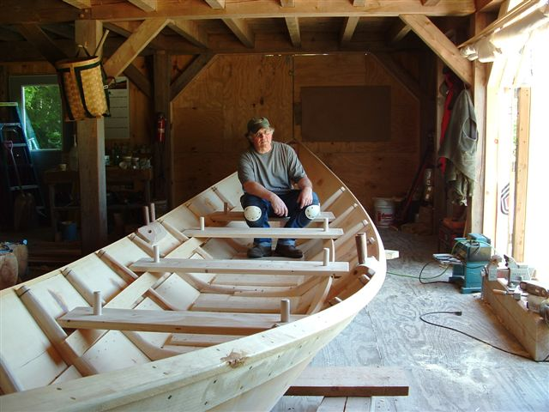
Batteau is a 28' Dave Connors-type batteau built by Dave Wylie and John Connors for the Madawaska Historical Society. This type is a small so-called 'pickboat' used to move floating logs, break jams or carry a small crew of men with pickpoles and peaveys. The boat is a two-plank model favored by Dave Connors.

Photo Courtesy of Dave Wylie

SNOWE, COLLINS ANNOUNCE $120 MILLION IN NEW
MARKETS TAX CREDIT ALLOCATION FOR COASTAL
ENTERPRISES OF WISCASSET

Funding to be Used for Community Investment
WASHINGTON, DC - U.S. Senators Olympia J. Snowe and Susan Collins today announced Coastal Enterprises, Inc. of Wiscasset has been awarded $120 million in New Markets Tax Credits (NMTC) by the U.S. Department of Treasury. “We are so pleased to announce that Coastal Enterprises of Wiscasset has been awarded $120 million in New Markets Tax Credits that can be used to foster development and economic growth throughout Maine,” Snowe and Collins said in a joint statement. “It is only through an investment in our future and in some of our disadvantaged communities that our children will have a bright economic future. That is the mission and spirit of the New Market Tax Credits – a mission that we all can agree is essential to our state.”

Coastal Enterprises, Inc. (CEI) will direct its NMTC loans and investments primarily to operating companies, (non-real estate for-profit and nonprofit entities), providing flexible debt for rural, natural resource-based businesses; small and medium-sized enterprises needing less than $2 million in capital; and high community-impact businesses with capital needs between $2 million and $20 million. The NMTC allocation will allow CEI to structure deals that make capital available at rates significantly below market, up to 400 basis points below prevailing rates, and on more flexible and favorable terms, such as substantial interest-only payment periods (often a full seven years), with loan amortizations that are much longer than standard, lower-than-standard cash flow coverage ratios, and higher-than-standard loan/value ratios. In addition, CEI will launch several small and medium enterprise revolving loan funds that will offer term debt in amounts of $100,000 to $2 million to help fund smaller projects.

CEI has been selected to receive an allocation of tax credits through the New Markets Tax Credit Program administered by the Department of the Treasury's Community Development Financial Institutions (CDFI) Fund. The New Markets Tax Credit (NMTC) Program permits taxpayers to receive a credit against Federal income taxes for making qualified equity investments in designated Community Development Entities (CDEs). Substantially all of the qualified equity investments must in turn be used by the CDE to provide investments in low-income communities. Under the current round, the CDFI Fund received applications from 254 entities requesting the authority to issue to their investors the aggregate amount of $28.3 billion in equity as to which NMTCs may be claimed. The CDFI Fund has awarded 63 organizations an aggregate total of $4.1 billion in NMTC allocation authority -- the allocation authority available this round.



SENATORS SNOWE, COLLINS ANNOUNCE MORE THAN $91,000 AWARDED TO NORTHERN MAINE DEVELOPMENT COMMISSION

WASHINGTON, D.C.—Senators Olympia J. Snowe and Susan Collins today announced that the U.S. Department of Agriculture (USDA) has awarded the Northern Maine Development Commission a grant in the amount of $91,428.57. The Commission will leverage $95,000 in outside funds to repair and/or rehabilitate 30 housing units in Aroostook County.

“The USDA Rural Development Housing Preservation Grant Program provides critical funds to organizations working in rural areas to improve housing conditions for disadvantaged residents,” said Senators Snowe and Collins in a joint statement. “We applaud the Northern Maine Development Commission for the work that it does to help build a healthy and diverse economy for all the people of Aroostook County.”

The USDA Rural Development’s mission is to increase economic opportunity and to improve the quality of life in rural communities. Rural Development has invested over $63 billion since 2001 to provide equity and technical assistance to finance and foster growth in homeownership, business development, and critical community and technology infrastructure. Over 1.1 million jobs have been created or saved through these investments.

For more information, please contact Joella R. McBreairty, NMDC, 11 West Main Street-Suite #104, Fort Kent, ME 04743 or call 834-5298 or e-mail at jmcbreairty@nmdc.org.



Upcoming Events
CDBG Recertification Course
August 17, 2006
Post 2 Augusta American Legion

MCDA General Membership Meeting
August 18, 2006
9:15 p.m.
Post 2 Augusta American Legion

CD Appreciation Day
August 18, 2006
9:15 p.m.
Post 2 Augusta American Legion

